UNITED STATES MARINE CORPS
COMBAT ENGINEER INSTRUCTION COMPANY
MARINE CORPS ENGINEER SCHOOL
PSC BOX 20069
CAMP LEJEUNE, NORTH CAROLINA 28542-0069

STUDENT OUTLINE

CONSTRUCTED OBSTACLES

C-14C01

BASIC COMBAT ENGINEER COURSE

M031302

10/06/2009

LEARNING OBJECTIVES.

1. TERMINAL LEARNING OBJECTIVES.

a. As a member of a team, given barbed wire, concertina wire, pickets, tools, tie wire, and safety equipment, construct wire obstacles to tie into existing natural or man made obstacles so enemy movement/maneuvers are fixed, turned, blocked or disrupted. (1371-CMOB-1001)

b. As a member of a team, given engineer tools and equipment, Class IV and/or Class V, expedient obstacle material, personal protective equipment (PPE), type of obstacle required, obstacle intent, and training area, construct field expedient obstacles to tie into existing natural or man made obstacles so enemy movement/maneuvers are fixed, turned, blocked or disrupted. (1371-CMOB-1002)

2. ENABLING LEARNING OBJECTIVES.

a. Without the aid of references, given a countermobility mission, explain, in writing, the principles of employment for wire obstacles per the references. (1371-CMOB-1001a)

b. Without the aid of references, identify the six types of wire obstacles used for counter-mobility per the references. (1371-CMOB-1001b)

c. Without the aid of references, given a countermobility mission, determine counter-mobility purpose (anti-personnel/anti-vehicular of each wire obstacle per the references. (1371-CMOB-1001c)

d. Without the aid of references, given proper tools, personal protective equipment (PPE), and a mission to construct of a wire obstacle, determine the picket spacing for the specified wire obstacle per the
references. (1371-CMOB-1001d)
e. Without the aid of references, given proper tools, personal protective equipment (PPE), and a mission to construct of a wire obstacle, layout wire (concertina/barbed) for the specified wire obstacle per the
references. (1371-CMOB-1001e)
f. Without the aid of references, given proper tools, personal protective equipment (PPE), and a mission to construct of a wire obstacle, properly connect/tighten components of wire obstacles (concertina/barbed) for the specified wire obstacle per the references. (1371-CMOB-1001f)
g. Without the aid of references, as a member of a team, given proper tools, personal protective equipment (PPE), and a mission to construct of a wire obstacle, construct a triple standard concertina entanglement to tie into existing natural or other man-made obstacles so enemy movement/maneuvers are fixed, turned, blocked, or disrupted as required by the mission while observing safety precautions per the references. (1371-CMOB-1001g)
h. Without the aid of references, as a member of a team, given proper tools, personal protective equipment (PPE), and a mission to construct of a wire obstacle, construct a 4 and 2 double apron fence to tie into existing natural or other man-made obstacles so enemy movement/maneuvers are fixed, turned, blocked, or disrupted as required by the mission while observing safety precautions per the references. (1371-CMOB-1001h)
i. Without the aid of references, as a member of a team, given proper tools, personal protective equipment (PPE), and a mission to construct of a wire obstacle, construct a 6 and 3 double apron fence to tie into
existing natural or other man-made obstacles so enemy movement/maneuvers are fixed, turned, blocked, or disrupted as required by the mission while observing safety precautions per the references. (1371-CMOB-1001i)

j. Without the aid of references, as a member of a team, given proper tools, personal protective equipment (PPE), and a mission to construct of a wire obstacle, construct a knife rest obstacle to tie into existing natural or other man-made obstacles so enemy movement/maneuvers are fixed, turned, blocked, or disrupted as required by the mission while observing safety precautions per the references. (1371-CMOB-1001j)
k. Without the aid of references, as a member of a team, given proper tools, personal protective equipment (PPE), and a mission to construct of a wire obstacle, construct a concertina road block to tie into existing natural or other man-made obstacles so enemy movement/maneuvers are fixed, turned, blocked, or disrupted as required by the mission while observing safety precautions per the references. (1371-CMOB-1001k)
l. Without the aid of references, as a member of a team, given proper tools, personal protective equipment (PPE), and a mission to construct of a wire obstacle, construct a four strand cattle fence to tie into existing natural or other man-made obstacles so enemy movement/maneuvers are fixed, turned, blocked, or disrupted as required by the mission while observing safety precautions per the references. (1371-CMOB-1001l)
m. Without the aid of references, state in writing the purpose of field expedient obstacles per the references. (1371-CMOB-1002a)
n. Without the aid of references, given an countermobility mission, state in writing the principles of employment for field expedient obstacles per the references. (1371-CMOB-1002b)
o. Without the aid of references, given an countermobility mission, state in writing the dimensions of log obstacles components for a given type of log obstacle per the references. (1371-CMOB-1002c)
p. Without the aid of references, given an countermobility mission, state in writing the spacing between support posts for a given type of log obstacle per the references. (1371-CMOB-1002d)
q. Without the aid of references, given an countermobility mission, state in writing the depth when emplacing support posts for a given type of log obstacle per the references. (1371-CMOB-1002e)
r. Without the aid of references, given an countermobility mission, state in writing the finished height of a given log obstacle per the references. (1371-CMOB-1002f)
s. Without the aid of references, given an countermobility mission, state in writing how to properly backfill a log obstacle per the references. (1371-CMOB-1002g)
t. Without the aid of references, as a member of a team, provided a mission, a designated area, and engineer tools, construct log obstacles to tie into existing natural or other man-made obstacles so enemy movement/maneuvers are fixed, turned, blocked, or disrupted as required by the mission while observing safety precautions per the references. (1371-CMOB-1002h)
u. Without the aid of references, state in writing the characteristics of an hedgehog obstacle per the references. (1371-CMOB-1002l)
v. Without the aid of references, state in writing the height of a concrete tetrahedron per the references. (1371-CMOB-1002m)

BODY

1. CLASSIFICATION OF OBSTACLES. All obstacles are classified in two broad categories, existing and reinforcing. Existing obstacles are natural features such as lakes, rivers, and mountains; or cultural features, meaning towns, religious locations, railroad embankments, etc. Reinforcing obstacles are placed on the battlefield to strengthen existing obstacles. Reinforcing obstacles include, but are not limited to, minefields, road craters and wire and expedient obstacles.

a. Purpose of Obstacles.

(1) Enhance the effectiveness of friendly anti-tank fires.

(2) Delay the enemy’s advance, upset his timing, disrupt and channelize his formations, and delay or destroy follow-on echelons.

(3) Enhance friendly economy of force measures

b. To accomplish the above purposes, we place obstacles with certain intents. Those intents are:

(1) Turn the enemy. Often times we will want to force the enemy into a certain area, which allows the commander to focus his fires in a concentrated location thereby maximizing his firepower.

(2) Fix the enemy. Fixing the enemy means to delay him in a certain location. While this may temporarily stop an enemy’s forward motion, it will not do so permanently. This delay allows for the targets to be acquired, fired on, and destroyed throughout the span of the engagement area while the target is in an unplanned static or near static position.

(3) Block the enemy. Blocking the enemy denies access to an area.

(4) Disrupt the enemy. Disrupting the enemy’s formations and his tempo will reduce his combat effectiveness while making him more vulnerable to our firepower. Obstacles will also disrupt the enemy’s logistics will also degrade his combat abilities.

b. Principles of Employment. In order to be effective, obstacles must be:

(1) Under friendly observation and covered by fire. Remembering that one of the reasons we will use obstacles is to place an enemy in the best position to kill him, we must have the obstacles covered with friendly fires. We also do not want the enemy to subvert our obstacles while we aren’t looking.

(2) Erected in irregular traces or staggered. Obstacles should never be built in a predictable geometric pattern.

(3) Tied in with other man-made or natural obstacles. Using existing obstacles saves time and effort on our part.

(4) Concealed from enemy observation. By incorporating terrain features such as reverse slopes, hedges, woods, and fence lines concealing their existence. Ideally, when the enemy runs up on an obstacle it is a surprise. This gives the enemy less chance to plan for a breach of our obstacles.

(5) Employed in depth. One obstacle will slow down the enemy and force him to use his breaching assets. Employing obstacle in depth will force the enemy to expend his breaching assets before they get through all of our obstacles.

(6) Coordinated with other elements of the defense. Obstacles are only one part of a defensive plan. They should compliment other elements just as those other elements should work in conjunction with the obstacles.

(7) Provided with lanes and gaps. These lanes and gaps allow for friendly forces to move through the obstacles for purposes such as reconnoitering the enemy, counter attacking, etc. These lanes and gaps should never be straight lined or obvious to the enemy.

(8) Of no advantage to the enemy. We should choose obstacles that suit our purposes with out giving the enemy aid (i.e. providing a covered position to attack our forces).

(9) Supports the maneuver commander’s plan.

2. WIRE OBSTACLES. (45 min) Wire obstacles are reinforcing obstacles and should be employed with the principles listed above. There are six types of wire obstacles that we will be discussing: Four Strand Cattle Fence, Double-Apron Fence, Triple Standard Concertina fence, Tangle Foot, Knife Rest and Concertina Roadblocks.

a. Tools and Materials:

(1) There are two types of wire that we use to construct obstacles,
Barbed wire and Concertina wire.

(2) The most common stake that we will use is the U-Shaped picket, also known as the engineer stake. Nearly any types of stake can be used to construct an obstacle when U-Shaped pickets are unavailable.

(3) We have special tools we use when working with wire:

(a) Wire gauntlets or gloves are used to handle the wire without damaging your hands.

(b) Stake drivers are used to drive longer u-shaped pickets.

(c) Sledge hammers are used to drive short pickets.

(d) Drift pins are used to twist/tighten wire.

(4) There are four methods of making ties when working with barbed wire:

(a) Post ties are used to secure the wire to posts. Wrap a bite of wire tightly around the post to keep it from sliding down the post or engage the wire in a notch when using the U-shaped picket. Then, keeping the wire tight, make at least two complete turns around the free or running end of the wire.

(b) To attach wires to the anchor stakes we use the Eye tie simply by making a loop around the anchor stake and twisting the wire around itself at least three times. This is the same as a post tie except that instead of wrapping a bite of wire around itself, you are wrapping a single strand.

(c) Apron ties are essentially the same as the post tie except that you are substituting a wire for the post. It is used when wires that cross need to be tied.

(d) Bread ties are made by using short pieces of wire to tie wires that cross instead of using the apron tie. These bread ties can be cut ahead of time in preparation for the construction.

b. Four Strand Cattle Fence. The four strand cattle fence is a basic wire obstacle we typically use. It is often used for administrative purposes but it can be utilized in a tactical environment (commonly used to mark minefields). It is made with barbed wire and U-shaped pickets.

(1) Construction.

(a) Eight men may be employed on short sections of this fence and up to 16 men on 300-meter (984 ft) sections. The two operations are laying out and installing pickets, and installing wire.

(b) Installation of Pickets. The working party is divided into two groups of approximately equal size. The first group carries and lays out long pickets at 3-meter (10 ft) intervals along the centerline of the fence, beginning and ending the section with an anchor picket. The second group installs the pickets.

(c) Installation of Wires. As the first task is completed, men move individually to the head of the fence and are organized into teams of two or four men to install wires. For four man teams, two men carry the reel and two men make ties and pull the wire tight. For two man teams, the wire must first be unrolled for 50 to 100 meters (164 to 328 ft), then the men come back to the head of the work and make the ties, or the wire may first be made up into bobbins to be carried and unwound by one man while the other man makes the ties. The first team installs the bottom fence wire, and draws it tight and close to the ground. Succeeding teams install the next wires in order.

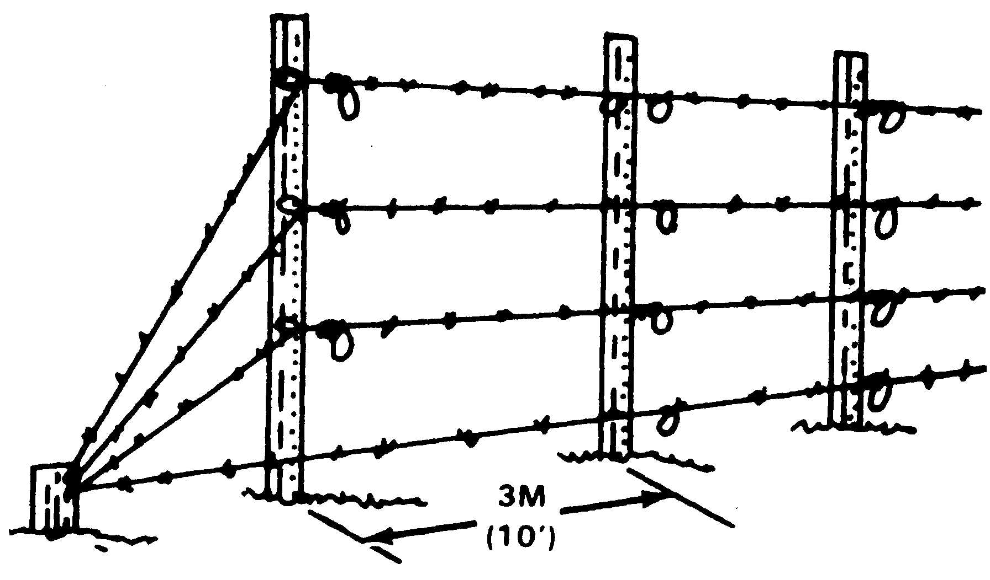

c. Double-Apron Fence. One of the two most commonly used wire obstacles. It is constructed with barbed wire. The double-apron fence is built around the four strand cattle fence. When we construct the “double-apron fence” we use either a “4 and 2” pace count or a “6 and 3” pace count. The type of fence employed will be dependant on the available materials, distance to cover, and available time to complete the obstacle.

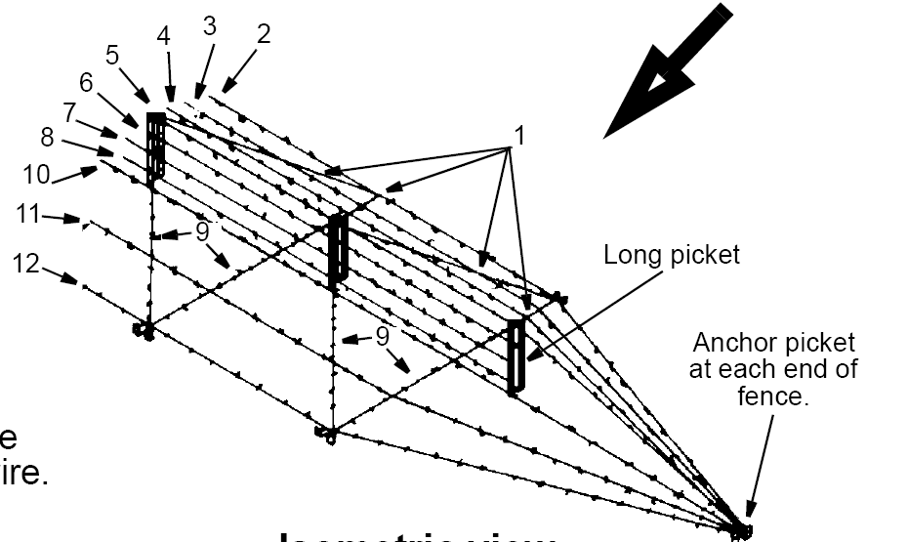

(1) Constructing The 4 And 2 Pace Double-Apron Fence.

(a) Operational layout and installation of pickets is to be completed with three squads.

1 First crew lays out long pickets.

2 Second crew lays out short pickets.

3 Third crew installs pickets. All long pickets will be installed using a u-shaped picket driver. Short pickets will be installed using a sledge hammer.

4 Erect from right to left as you face the enemy. Always work from friendly side.

5 Long pickets are 4 paces apart on centerline.

6 Short pickets are centered between long pickets and two paces off of centerline. Place your back against the first long picket and walk 2 paces on centerline. Next, mark the deck so you know where the center is between long pickets. Then, take 2 paces to the left and to the right to get the exact location of short pickets.

7 End anchor pickets are 4 paces from the first and last long picket.

8 Operational layout and installation of wire (men are organized into two crews of four men each). Before handling any type of wire, barbed wire gauntlets must be used. A post tie will occur whenever a barbed wire line crosses a picket.
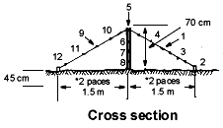

a The first wire is the enemy diagonal wire. It runs from the tops of the center pickets to the short pickets and should be tight.

b The second wire, is the enemy side trip wire. This wire begins at the anchor picket and is secured to the diagonal wires just above each short picket using the apron tie.

c The No. 3 wire is an apron wire on the enemy side of the fence. It is secured to the first diagonal wire, and thereafter to each alternate diagonal, and then to the last diagonal wire. The No. 4 wire is also an apron wire on the enemy side of the fence. It is secured to the first diagonal wire (No. 1), thereafter to the diagonal wires which are not tied to the No. 3 wire, and then to the last diagonal wire. Apron wire Nos. 3 and 4 are equally spaced along the diagonal wire.

d The No. 5 wire is the first one that is not started from the end anchor picket. It is started at the first long picket and ended at the last long picket. It is secured with an eye tie and is stretched tightly to prevent passage over or under it.

f Wire Nos. 6, 7, and 8 complete the center portion (Four Strand Cattle Fence) of the fence and are secured to the long pickets with an eye tie. They also start at the first, and end at the last, long picket. These wires (Nos. 6, 7, and 8) form the backbone of the fence and are drawn up tightly to hold the pickets in position.

g Wire No. 9 is the diagonal apron wire on the friendly side of the fence and is secured with a post tie to all pickets. Wire Nos. 10 and 11 are apron wires, and wire No. 12 is the trip wire on the friendly side of the fence. Wire No. 12 is installed in the same manner as wire No. 2.

i If the fence is not satisfactorily tight when installed, wires are tightened by racking (twisting) the wire with a drift pin.

(2) Double-Apron Fence 6 and 3 Pace. Erected in the same manner as the 4 and 2 pace. However, the pace count will change by substituting 6 paces instead of 4 and 3 paces instead of 2.

d. Triple Standard Concertina. This is a very common wire obstacle that is quick to install and is a formidable obstacle. It is erected quickly and is difficult to cross, cut, and crawl through. Although the materials for a Triple Standard fence is heavier than an equal distance of materials used for a double-apron fence, it is constructed in about half the time. As the name implies, the Triple Standard is constructed with Concertina wire and consists of two lines of concertina serving as a base, with a third line resting on top.

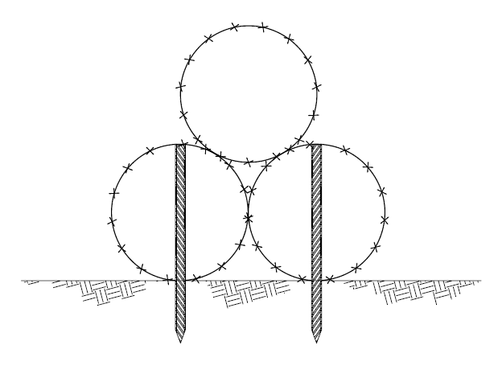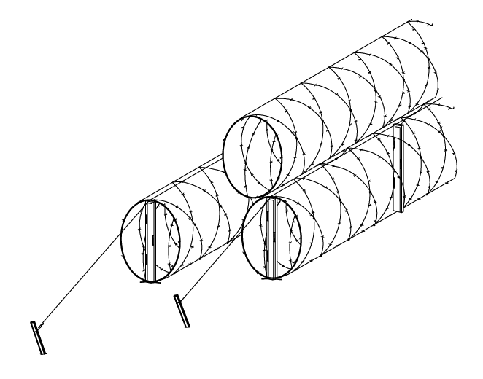

(1) All lines are installed with staggered joints.

(2) Space pickets as follows: Erect from right to left as you face the enemy. Again work from friendly side.

(a) Long pickets are 5 paces apart.

(b) Anchor pickets are placed 2 paces from each end of each row.

(c) Enemy and friendly rows of pickets are 3 ft apart.

(d) Friendly picket row is offset from enemy row.

(3) Construction Procedure-Triple Standard Concertina.

(a) Phase 1 (3 crews).

1 First crew lays out all pickets.

a There will be one anchor picket at the end of each line.

b The long pickets will start five feet from the anchor picket and will be spaces 5 paces apart.

2 Second crew installs all pickets.

3 Third crew lays out all concertinas.

a Lay one concertina in front of third picket on enemy side.

b Lay two concertinas to rear of third picket on enemy side.

c Remove binding wire and place on handles.

d Repeat same performance every fourth picket thereafter.

(b) Phase 2 (4 man teams). Install all rows of wire and secure with horizontal wire.

1 Install front row concertina and horizontal wire. Drop concertinas over pickets. Join concertinas together using staples or barbed wire ties.

2 Install horizontal wire across the enemy side row of concertina securing with either staples or barbed wire ties, two to three times between each picket.

3 Install rear row concertina and horizontal wire.

4 Install top row concertina and tack or tie to the rear horizontal wire, two to three times between each picket.

(c) A 300-meter fence is a platoon task normally requiring 1-hour to complete.

e. Tanglefoot. Tanglefoot is used where concealment is essential and to prevent the enemy from crawling between fences and in front of emplacements. Constructed with barbed wire, tangle foot is constructed at varying heights.

(1) Tanglefoot should be employed in a minimum depth of 9 meters (30ft).

(2) Short pickets will be used and spaced at irregular intervals from 75cm to 3 meters (2.5 to 10 feet) or 1-4 paces.

(3) The height of barbed wire should vary between 25 to 75 cm (9 to 30 inches).

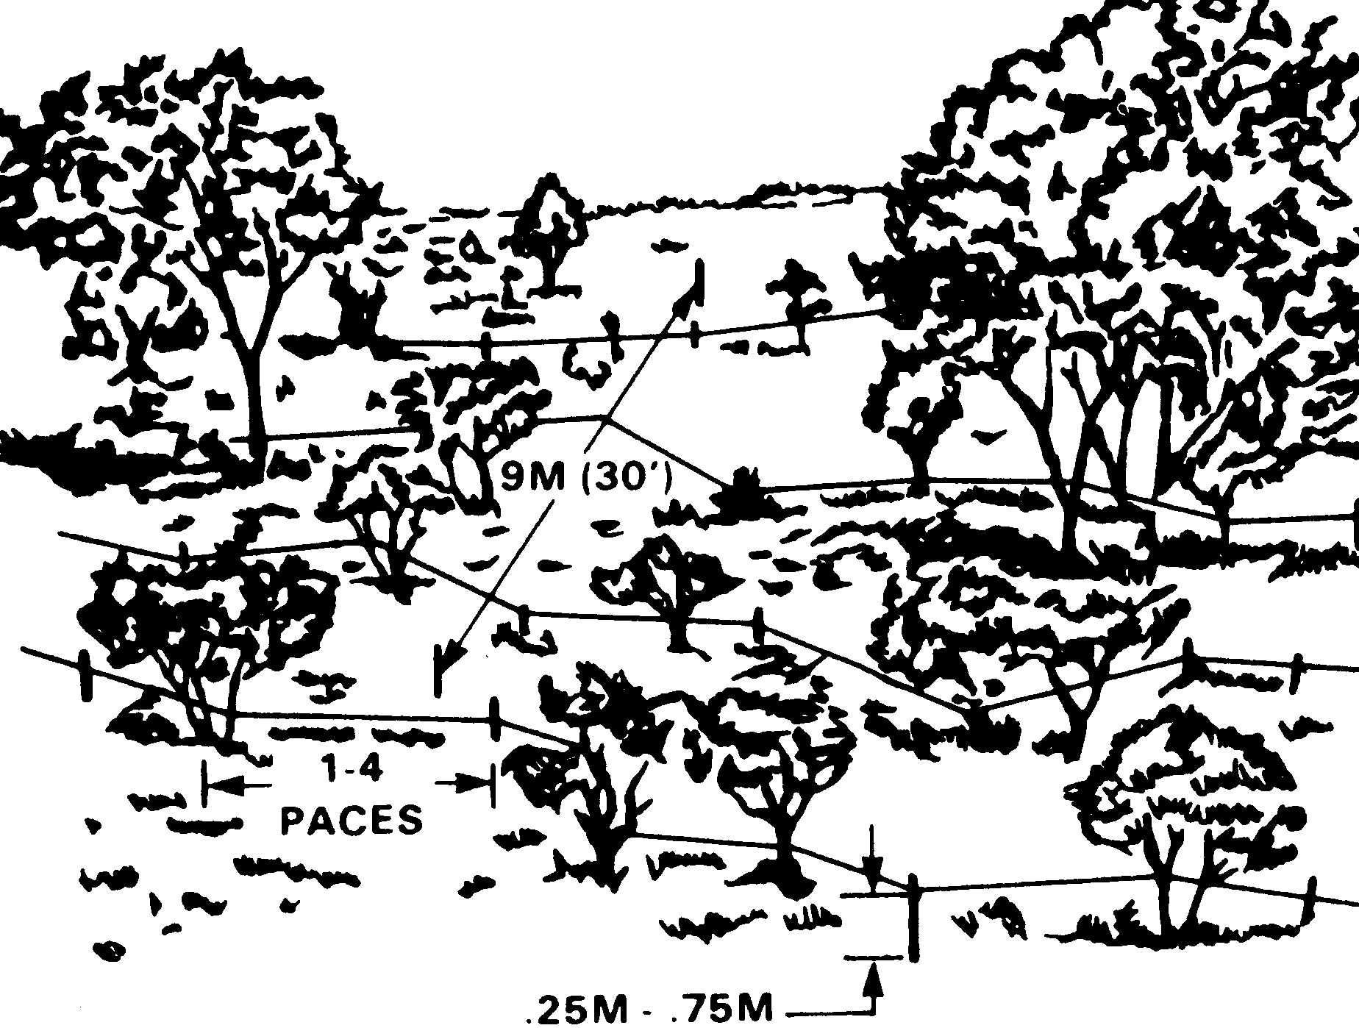

f. KNIFE REST. A knife rest is used wherever a readily removable barrier is needed, for example, at lanes and gaps in wire obstacles or at roadblocks.

(1) Knife rests can be constructed out of wood or metal and consist of two cross members and one horizontal member. The entire structure is strung with barbed wire.

(2) Knife rests dimensions will vary based on your needs and materials on hand but it is recommended that they be 4.5 meters (15ft) in length and 1.2 meters (4ft) in width and height. If you make the knife rest much larger it will be difficult to move by hand and if you make it much smaller it would be too easy to move.

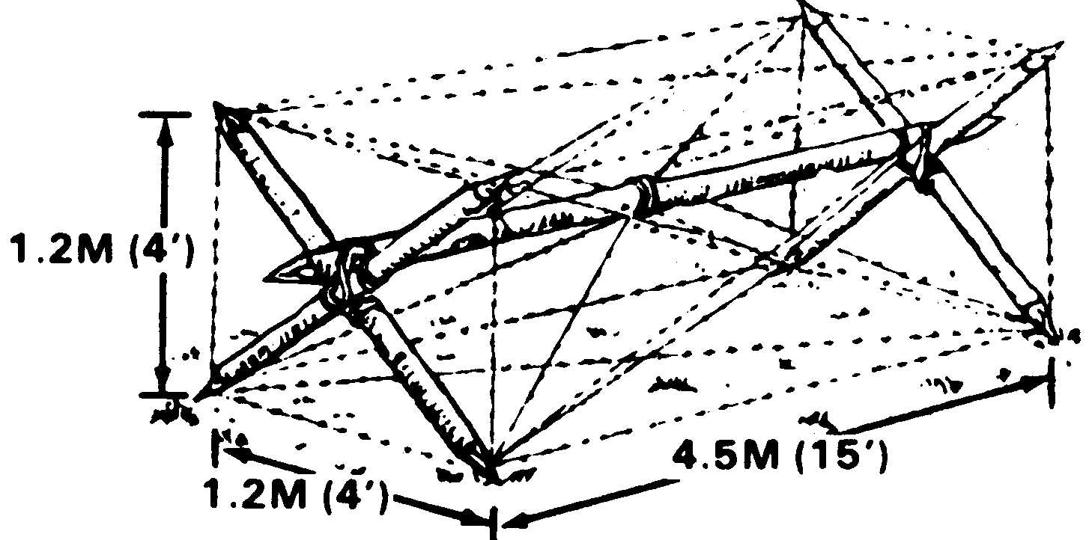

g. CONCERTINA ROADBLOCK. As the name implies, the Concertina Roadblock is used to block a road access for not only troops but also vehicles. A series of concertinas will stop wheeled vehicles when employed with a minimum depth of 10m (33ft). When employed in greater depth it can stop tracked vehicles. It is constructed as follows:

(1) Place three long u-shaped pickets 5 paces apart per coil. The pickets should be lightly anchored.

(2) Place and tie a horizontal wire on top of each individual coil. The horizontal wire will be tied to each individual long picket and secured on each end by an anchor picket.

(3) The width and depth of the road block will vary based on the situation. The depth will also vary based on available materials.

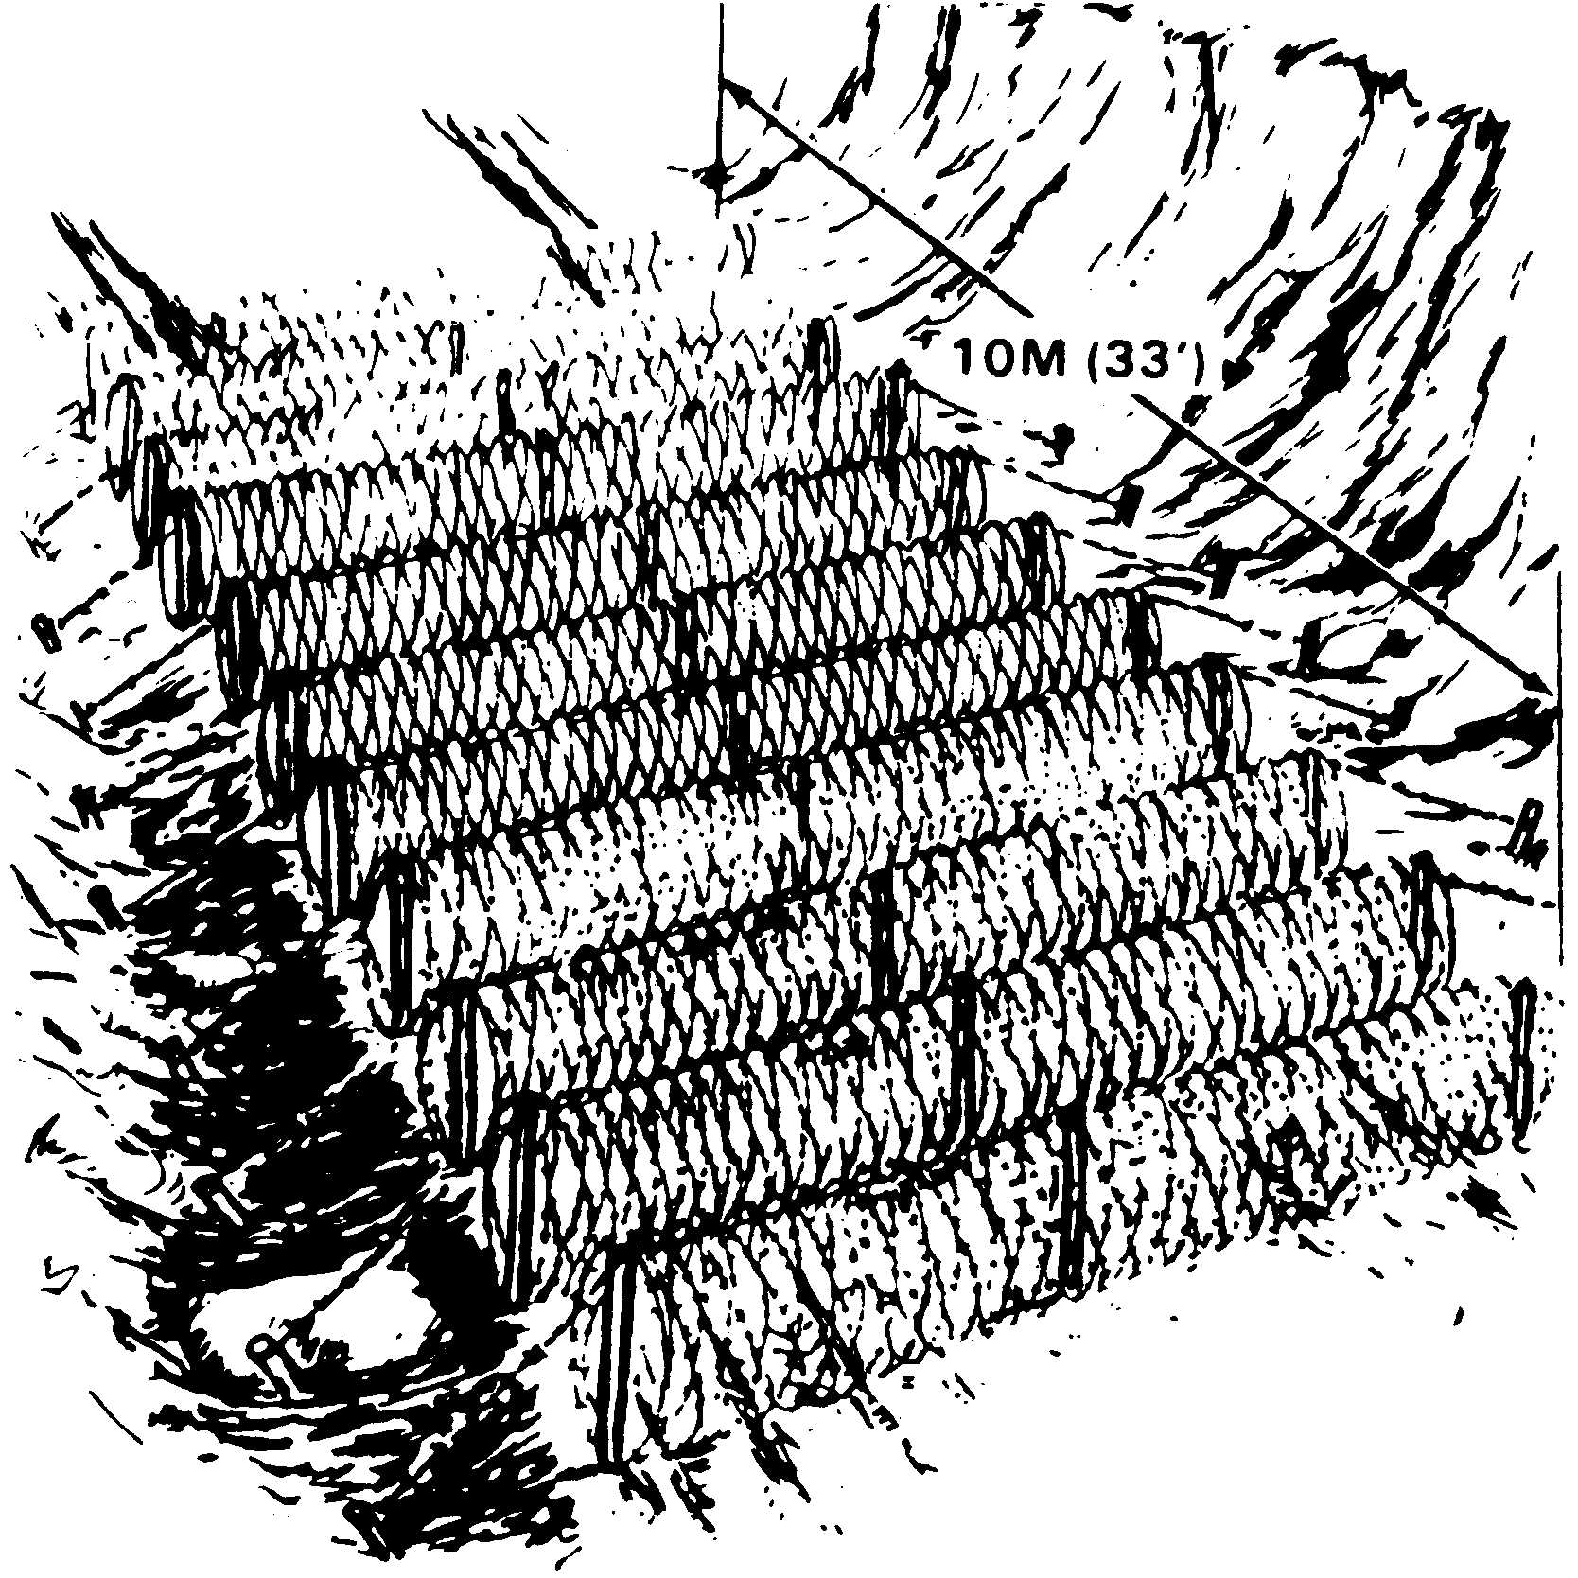

3. LOG OBSTACLES. There are many different types of log obstacles that can be constructed using local materials. Log obstacles are most effective when the lack of a bypass forces the enemy to breach them. Although they are time and labor intensive, and locations for their employment are limited, they do not require much logistical support. Log obstacles can be constructed entirely by hand. The availability of chain saws and bucket loaders or backhoes will significantly reduce construction time. Log obstacles can and should be used in conjunction with other obstacles to increase their stopping power. It should also be noted that while these are called log obstacles, other materials, such as pipe or steel I-beams, can be used to construct many of these obstacles just as effectively.

a. Log Hurdles.

(1) Log hurdles can be constructed using logs and should be built to a height of 18 inches. When using logs 10 inches in diameter but less than 18 inches, the obstacle can be constructed of multiple logs tied together to achieve the proper height.

(2) On level ground, log hurdles will not stop tanks, but will cause them to slow down. Log hurdles can stop tanks on uphill grades. Hurdles will improve the effectiveness of other obstacles by slowing enemy vehicles and making them more vulnerable to direct weapon fire.

(3) The significant factor is determining how high to build the hurdle. The hurdle should be sited on the steepest part of the slope and as near to the top as possible.

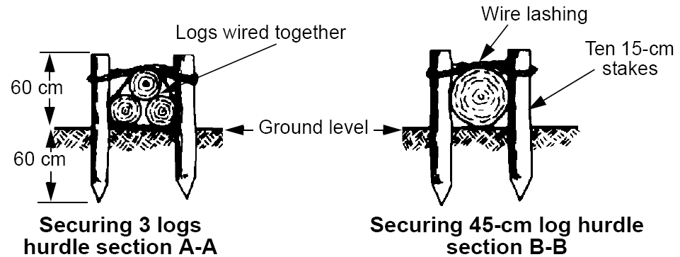

(4) Log Hurdle Construction.

(a) Materials needed:

1 Four posts, 4 foot in length (two per side, unless road way or log is greater than 14 feet).

2 Logs roadway width long or shorter.

3 Wire to secure the logs to post.

(b) Procedures:

1 Lay long log/logs across the road, perpendicular or at slight angle.

2 Dig two holes approximately 1/4 to 1/3 from each end. Holes should be two feet deep. Logs over 14 feet long require additional posts in the center.

a Put all post in position next to log/logs.

b Wire logs to post.

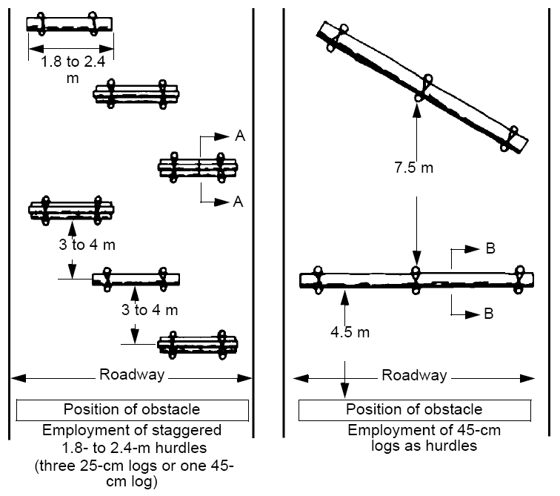

b. Log Cribs.

(1) Rectangular or Triangular log cribs are used effectively as roadblocks where standing timber is available, and where such an obstacle cannot be readily bypassed. Unless substantially built, obstacles of this type are not effective against heavy-tracked vehicles. Filling them in with earth strengthens cribs. It is preferable to obtain the earth by digging a shallow ditch in front of the obstacle. Log hurdles in front of a log crib will force vehicles to reduce speed and add to the effectiveness of the roadblock.

(2) Construction of a Rectangular Log Crib.

(a) Materials needed.

1 Twelve posts, 10 feet in length (six posts per wall on post opposing design); or Ten posts, 10 feet in length (five posts per wall on off set post design).

2 Two anchor posts, 4 feet in length (one buried behind each brace on back of wall).

3 Four or six pieces of diagonal bracing, 6 feet in length (placed on rear of front and back walls).

4 Horizontal logs – a minimum of 8 inches in diameter. The length will vary depending on available resources and the area to be obstructed. You will need as many logs as required to obtain a finished height of 5 feet on both walls.

5 Wire to secure logs to post.

6 Earth, debris or rubble to fill the crib.

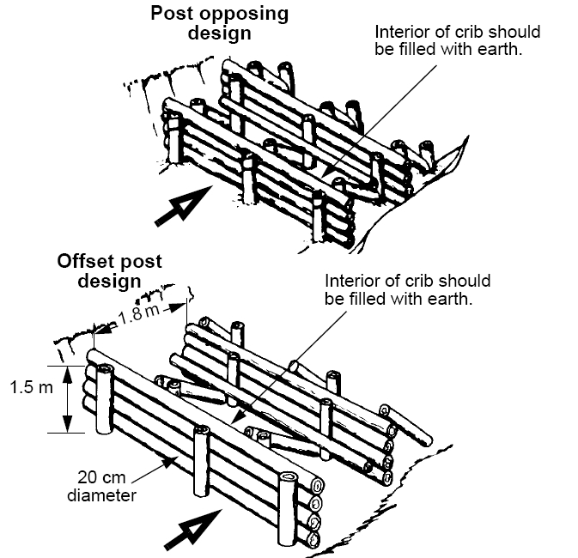

(b) Procedures:

1 Lay out a log across the roadway.

2 Next to the log, dig a hole 1/4 to 1/3 of the way in from each end on both sides of the log and 5 feet deep for each post.

3 Place a 10-foot post into each hole next to the log.

4 Continue to lay logs across the roadway until your wall height is 5 feet.

5 Measure out 6 feet for diagonal bracing (on backside of the front wall).

6 Lay out a log across the road (for the 2nd wall).

7 Dig a hole 5 feet deep for each post on back wall.

8 Place a 10-foot post into each hole next to the log.

9 Continue to lay logs across roadway until your wall height is 5 feet.

10 Measure out 6 feet for diagonal bracing on back wall.

11 Dig holes 2 feet deep (for 4 feet anchor post).

12 Place four-foot anchor posts into holes.

13 Put up all diagonal bracing.

14 Wire logs to post.

15 Fill the center with earth from the ditch dug in front of the obstacle.

(3) Triangular log crib. Similar in nature to the rectangular log crib except that the triangle completely contains the fill material (if used).

(a) Materials needed:

1 Twelve posts - 10 feet in length.

2 Horizontal logs – a minimum of 8 inches in diameter. The length will vary depending on available resources and the area to be obstructed. You will need as many logs as required to obtain a finished height of 5 feet on both walls.

3 Wire to secure logs to post.

4 Earth, debris or rubble to fill center.

(b) Procedures:

1 Lay (3) horizontal logs on roadway to form a triangle. (Point faces enemy direction).

2 Dig holes five feet deep and 2 paces from the ends for 10-foot post (dig inside holes first, then outside holes).

3 Place 10-foot post into holes next to logs.

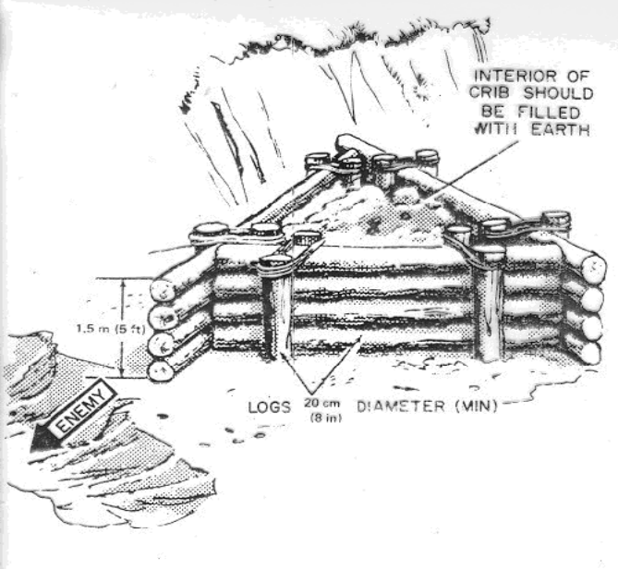

4 Build all 3 walls simultaneously in a counter clockwise order.

5 Wire logs to post with heavy duty gauge wire.

6 Fill the center with earth from ditch dug in front of obstacle to help reinforce and strengthen the obstacle.

c. Log Posts

(1) Log Posts are among the best anti-vehicular obstacles because each post presents breaching problems to the attacker. There are no fast methods of breaching a belt of posts. Normally, the attacker will try to bypass such an obstacle. Therefore, post obstacles should be placed where bypass requires much time and effort. Timber posts should be a minimum diameter of 16 inches (40cm). When using timber posts, hardwood timber is the best, but others can be utilized. Other materials can also be used such as concrete posts, heavy pipe, or I beams.

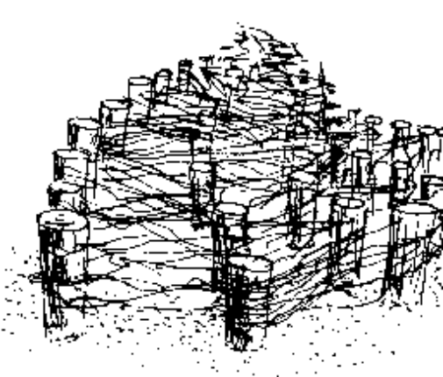

(2) Constructing a Log Post obstacle.

(a) Material needed:

1 8-foot to 9-foot post with a diameter of 16 inches (as many as necessary to complete an obstacle barrier).

(b) Procedures:

1 Dig holes 5 feet deep (as many as needed).

2 Post positioned 1 - 2 meters apart staggering each row.

3 Place post in the ground, either vertically or at a slight angle toward the enemy (height should vary between 30 to 48 inches).

4 If time permits, barbed wire may be used between posts. The barbed wire should crisscross inside the dead space. The dead space is the space between the posts on the inside.

4. Steel Obstacles: Urban environments and environments with a lack of standing timber calls for obstacles constructed from other materials. One obvious steel obstacle would be the Steel Post obstacle (covered under Log Obstacles). The following are examples of obstacles that can be constructed using steel. Tetrahedrons and hedgehogs target the mounted threat. These obstacles can also be used underwater.

a. Hedgehogs as shown below are relatively lightweight for the obstacle effect they provide, and they are quickly installed or removed. They are designed to revolve under wheeled vehicles and puncture them or to belly up tracked vehicles. Unless kept under observation and covered with fire, the enemy can readily move them aside. They are well adapted for use in vegetation high enough to afford complete or partial concealment. Exposed parts should be painted to blend with the background.

(1) Hedgehogs are made up in rear areas, using three pieces of material about 4 in. by 4 in., 4 ft. long, and .4 in. steel plate about 20 in. square.

(2) A hedgehog of this size weighs about 160 lb.

(3) Hedgehogs are used in rows, with at least 150 hedgehogs to each 100 meters (328 ft.) of front which is to be protected in this manner.
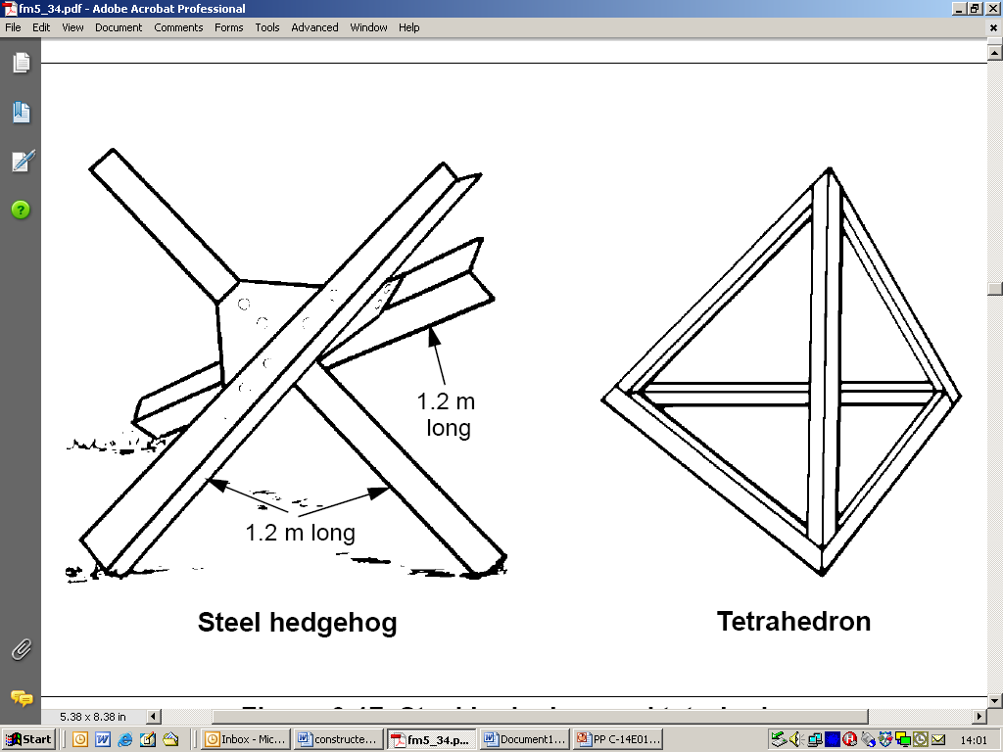
b. Tetrahedrons are pyramids with a triangular base and are employed in a manner similar to that of hedgehogs.

(1) They are usually made of 10 cm by 10 cm by 1.5 cm (4 in by 4 in. by .6 in.) angles, the base and sides in the shape of equilateral triangles, 1.5 meters (5 ft.) on a side.

(2) Their finished height is approximately 1.2 meters (4 ft.).

c. Hedgehogs and tetrahedrons make an effective obstacles in water (i.e. to protect a beachhead) and in Urban terrain.

d. Due to their relatively light weight hedgehogs and tetrahedrons are useful at closing gaps and lanes in a defensive positions.

5. CONCRETE OBSTACLES. Concrete is perhaps the most readily available building material in the world. When time permits it can be cast in many shapes and sizes. There are logistical and time requirements for constructing concrete obstacles that must considered.

a. Cubes are concrete obstacles of approximately cubical shape, set in irregular rows. Because of the weights involved and the simplicity of erecting forms for cubes, these obstacles are best cast in place if the situation permits. A cube of 1.2m³ requires about 2.4 cu yd. of concrete and weighs slightly less than 5 tons.

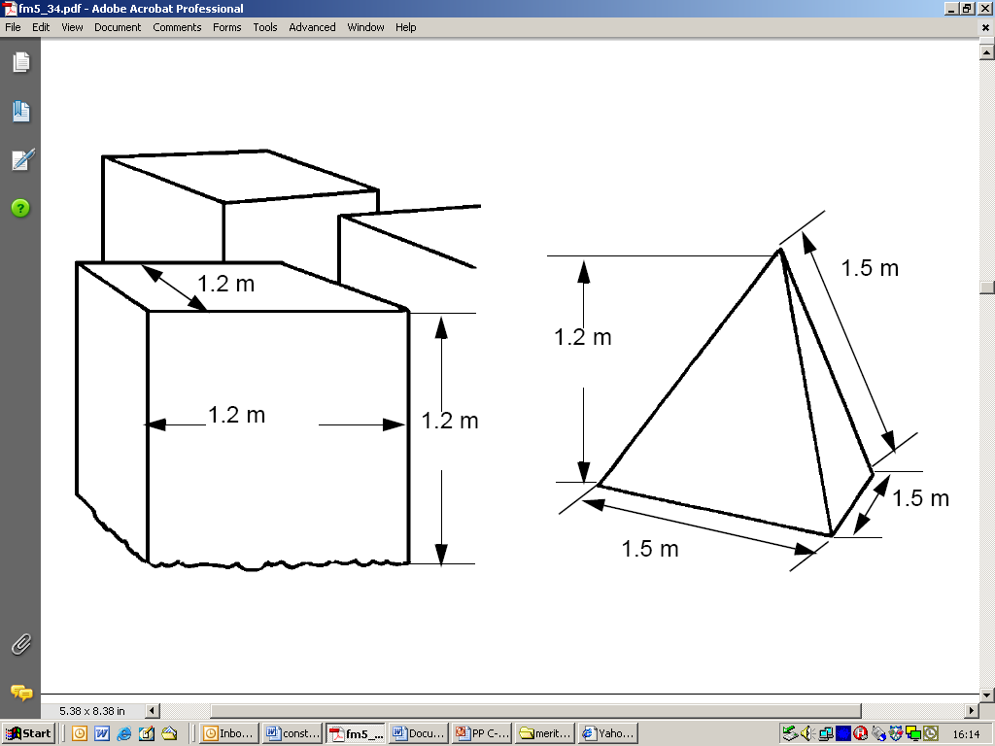

b. Cylinders. Concrete obstacles of cylindrical shape are usually smaller than cubes and are light enough to be precast. Their use is similar to that of cubes, and they may be preferable in situations in which precast obstacles are the type required.

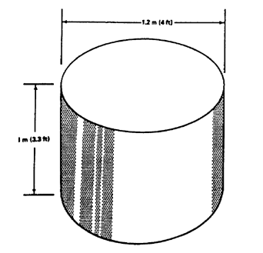

(1) Cylinders may be precast in forms made of lightweight sheet metal which need not be removed.

(2) A cylinder one meter in height and 1.2 meters in depth requires 1.3 cu yd. of concrete and weighs approximately 1.5 tons.

(3) Pipes can be filled with concrete either before or after placing them in position.

c. Tetrahedrons. Concrete tetrahedrons are pyramids with base and sides of equilateral triangles, 1.5 meters (5 ft.) on a side. A tetrahedron of this size has a vertical height of about 1.2 meters (4 ft.), requires 1.05 cu yd of concrete, and weighs about 1.1 tons.

d. When there is a need for movable obstacles lifting loops can be cast into the individual obstacles and/or precast slots for forklift tines as illustrated below.

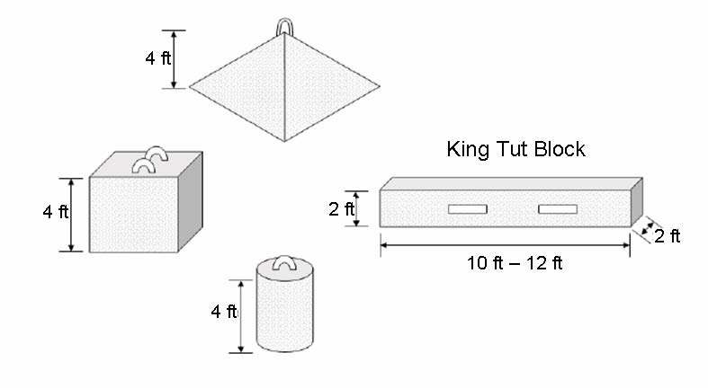

6. Improvised Obstacles. Engineers design improvised obstacles with imagination and ingenuity while using available materials and other resources. Possible improvised obstacles include the following:

a. Ditches, either pre-existing or those dug by HE or explosive means, make a formidable obstacle for tracked and wheeled vehicles when constructed in the right dimensions.

b. Rubbled masonry buildings can be piled or used to fill containers such as log cribs, large diameter pipe sections, and/or HESCO containers.

c. Controlled fires.

d. Flooded areas created by opening floodgates or breaching levees.

e. Vehicles can be used as a movable obstacle to close gaps or lanes. Damaged vehicle hulks can be used as roadblocks.

f. Other measures such as burying heavy equipment tires half way and in close proximity as illustrated below. 55 gallon drums or similar barrels can be filled with concrete, soil, or water to create temporary obstacles.

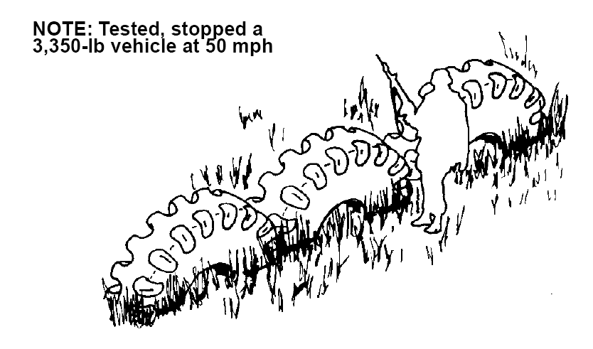

Engineers are the masters of terrain. We shape and modify the battlefield as a means of improving and amplifying our firepower while maximizing our economy forces. We accomplish this by using the principles and the obstacles discussed here as well as those that we can devise from our own imaginations.

REFERENCES
FM 5-102 Countermobility
FM 5-34/MCRP 3-17A Engineer Field Data

